Chapter 4

Implementation and Coding

4.1 Introduction

This chapter covers the role of various subsystems/modules/classes along with implementation details listing of the code for the major functionalities. The system consists of an IoT node (Arduino UNO, Node MCU, Ultrasonic sensor connected together), which sends distance data to the backend on the Apache server. This data is displayed on the GUI of the React.js front end. The network traffic is monitored by the TShark script and dumped in the file.csv. The Django Python backend reads this data in real time, feeds it to the ML model based on Random Forest and classifies it either as normal or attack. This data is sent to the front end and displayed in the form of a notification.

4.2 Module-wise Details

4.2.1 IoT Node
The IoT node consisted of 3 devices – Arduino UNO, Node MCU, Ultrasonic sensor.
4.2.1.1 Ultrasonic sensor – Its end goal is to measure distance. It emits ultrasonic waves and receives them.
4.2.1.2 Arduino UNO – This controls the ultrasonic sensor, measures the time between sending and receiving the waves which is used to calculate the distance from the object using the formula-
distance= duration*0.034/2
4.2.1.3 Node MCU – The distance data is sent from Arduino to Node MCU using a serial communication. This is then sent to the php script on the Apache server by connecting to the wifi network.

4.2.2 TShark Script
TShark is a command line utility, a network packet analyzer that is used to capture packets from a live network and dump the traffic data into file.csv which is later read by the backend Python script. It captures the fields – frame number, frame time, frame length, source mac address, destination mac address, source IP address, destination IP address, IP protocol, IP length, TCP length, TCP source port, TCP destination port, packet info.

4.2.3 Apache Backend
The apache backend has 1 php script – server.php and 1 text file – datastorage.txt.
4.2.3.1 server.php – This php script is used to receive distance data from the IoT node and save it in the datastorage.txt.
4.2.3.2 datastorage.txt – This text file stores the 10 most recent distance values sent from server.php. The older values are deleted by server.php. This data is used by the front end to display graphics in Dashboard.js.

4.2.4 ML model
4.2.4.1 Dataset – The dataset needed to create the ML model was made using traffic data gathered from the TShark script. Multiple attacks (wrong setup, DDOS, Data Type Probing, Scan Attack, MITM) were performed while monitoring the traffic. The records were labeled according to known parameters used to identify particular type of attack.
4.2.4.2 Model Creation – The generated dataset was filtered for erroneous data in dataFilteration.py, resampling was done to deal with the issue of lesser attack data than normal data in resampling.py, then it was divided into training, testing datasets and a Random Forest classifier was trained based on training data in model.py. This was tested using the test data and later optimized. This model has been used in consumers.py in the Django backend for real time attack classification.
This can be better understood from the following sequence diagram.
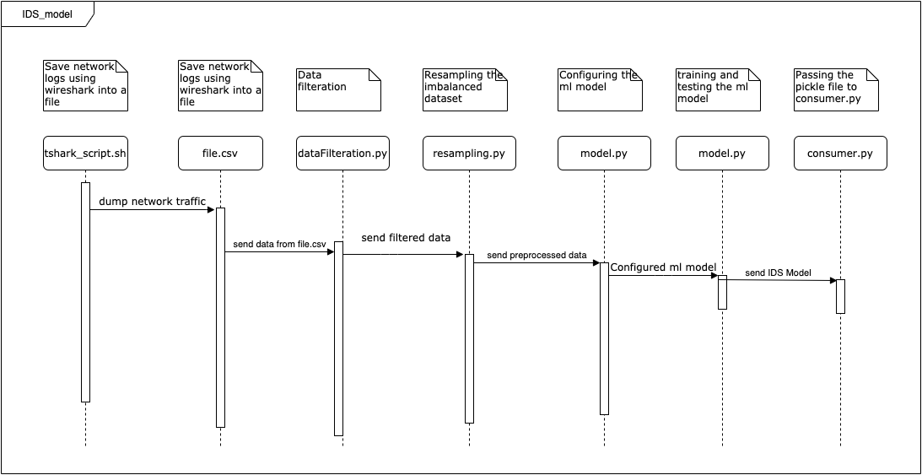
Fig 4.1 ML model module

4.2.5 Notification
The notification module is responsible for displaying the notification to the user whenever an attack has been detected in the IoT network. A web socket (attackNotif ws) is created between the React.js front end and Django backend to send notification data from BE to FE whenever an attack is detected. The ws starts the real time read loop in consumers.py which takes the data from file.csv, processes it and constantly keeps feeding to the ML model. The model makes classification (normal or attack) in real time and sends a notification if an attack is detected. This notification is displayed in the front end. This can be better understood from the following sequence diagram.
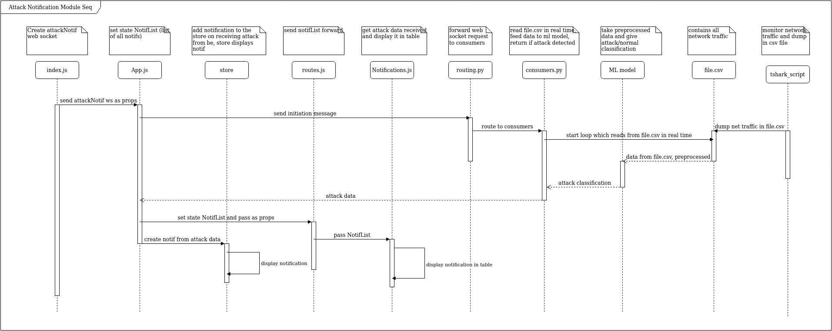
Fig 4.2 Notifications Module

4.2.6 Network Logs
The network logs module is used to display the traffic in the IoT network in real time. Similar to the notifications module, the web socket is created which initializes the loop in consumers.py that fetches traffic data from file.csv in real time. This data is sent to the FE where it is displayed. It updates in real time so the user can monitor IoT network traffic. This can be better understood from the following sequence diagram.
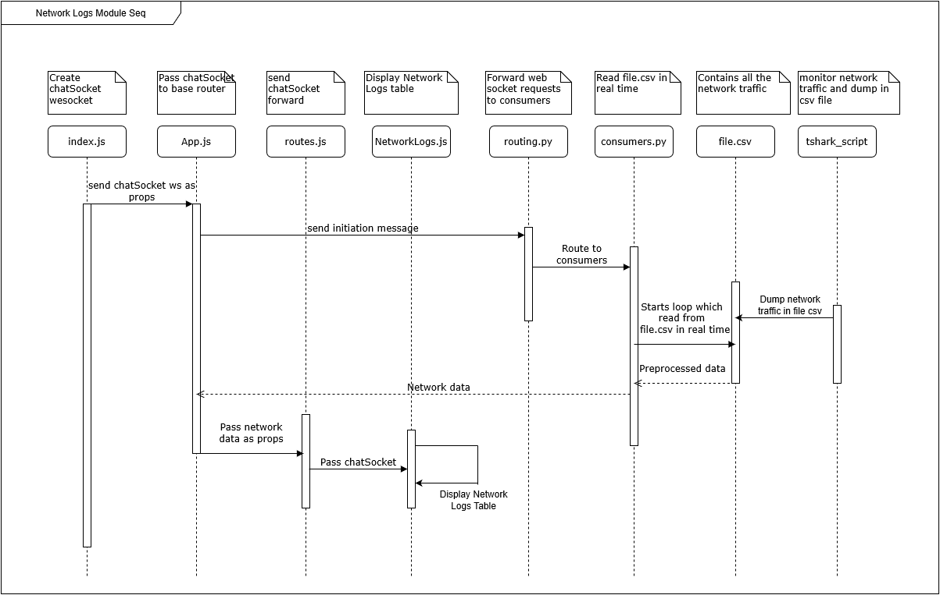
Fig 4.3 Network Logs Module

4.2.7 Dashboard
The dashboard module displays the distance data received from the IoT node with the help of graphics, thereby simulating the applications of the IoT network. A web socket is created between the FE and the php script websockets.php. An initiation message is sent which triggers the loop in the php script which reads the data from datastorage.txt and constantly sends this data to Dashboard.js where the node activity is shown. This can be better understood from the following sequence diagram.
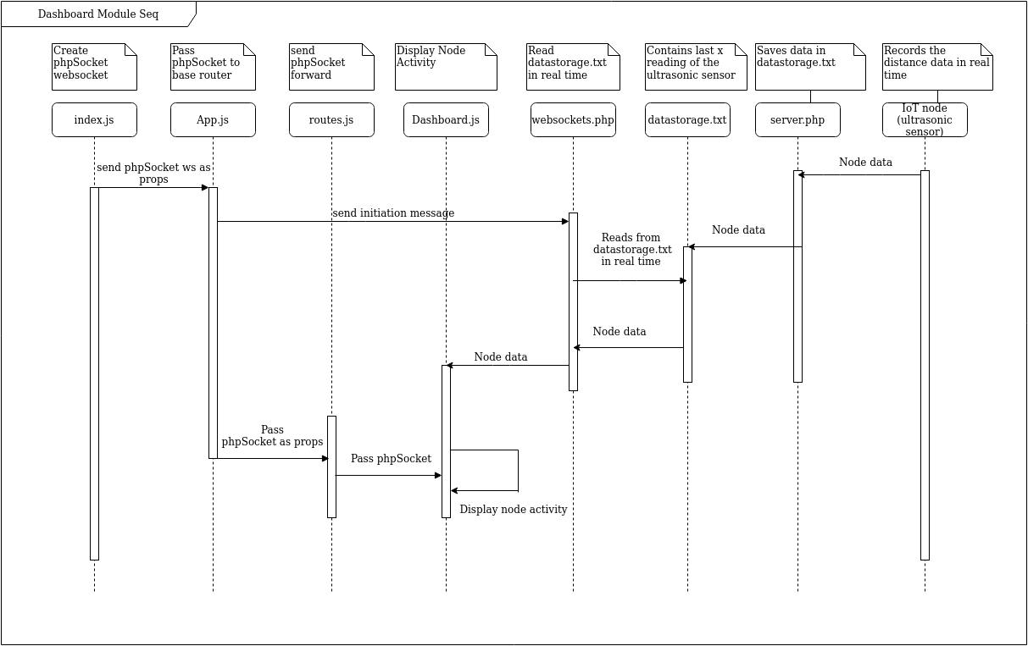
Fig 4.4 Dashboard Module

4.2.8 Visualisations
Visualisations modules showcases the data exploration, preprocessing and comparisons in results from the dataset and ML model. It has the visuals – ML model comparison, types of attack, types of protocol, correlation matrix, confusion matrix, effects of oversampling. The results were obtained in the python files dataFilteration.py, resampling.py, modelCompare.py, dataVisual.py and displayed in the visualisations module. This can be better understood from the following sequence diagram.
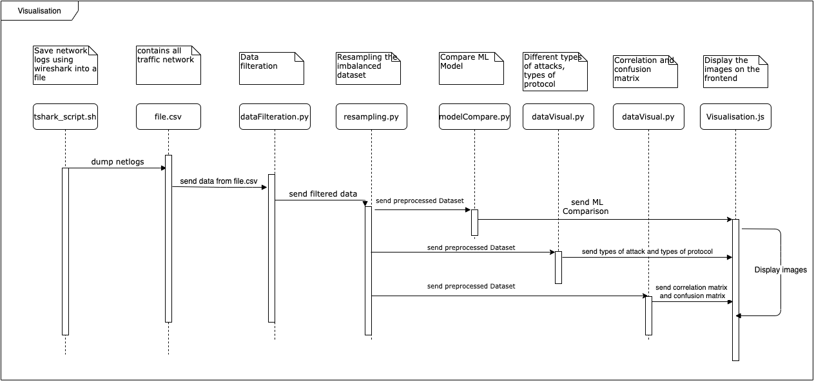
Fig 4.5 Visualisations Module
4.3 Code Listing

The code for this project is available on https://github.com/s3r-be. Following are important snippets of code from the modules of the project.

4.3.1 IoT Node
4.3.1.1 Arduino UNO
// send the ultrasonic wave
// Sets the trigPin on HIGH state for 10 micro seconds
digitalWrite(trigPin, HIGH);
delayMicroseconds(10);
digitalWrite(trigPin, LOW);

// Reads the echoPin, returns the sound wave travel time in microseconds
duration = pulseIn(echoPin, HIGH);

// Calculating the distance
distance= duration*0.034/2;
ArduinoUno.print(distance);
ArduinoUno.println("\n");
Serial.println(distance);
delay(100);

4.3.1.2 Node MCU
// connecting to wifi
WiFi.begin(ssid,password);
Serial.println();
Serial.print("Connecting");
while( WiFi.status() != WL_CONNECTED ){
delay(500);
Serial.print(".");
}

// send distance data to server.php
if (WiFi.status()==WL_CONNECTED)
{
HTTPClient http;
String url="http://" + ip + "/ids/server.php?data="+d;
http.begin(url);
http.addHeader("Content-Type","text/plain");
int httpCode=http.GET();
String payload=http.getString();
Serial.println("While sending I received this from server : "+payload);
if (payload=="SUCCESS. Data written in file."){
sres=1;
} else {
sres=0;
Serial.println("wrong or no payload!");
}
http.end();
net=1;
}

4.3.2 TShark script
#!/bin/bash

echo s3rbeproj | sudo -S `#to get sudo permissions`\
tshark `#run tshark`\
-T fields -e frame.number -e frame.time -e frame.len -e eth.src -e eth.dst `#give fields to capture`\
-e ip.src -e ip.dst -e ip.proto -e ip.len -e tcp.len -e tcp.srcport -e tcp.dstport -e _ws.col.Info \
-E header=y -E separator="$" -E quote=n -E occurrence=f `#set headers, separator as comma, double quotations, first occurrence`\
> file.csv `#dump into file.csv`\
-i wlp3s0 `#interface wifi`

4.3.3 Apache backend – server.php
// receive data passed to the script
$val = $_GET["data"];
$fileContent=$val."\n";
$filename = "datastorage.txt";
// append data to datastorage.txt
$fileStatus=file_put_contents($filename,$fileContent,FILE_APPEND);
if($fileStatus != false)
{
echo "SUCCESS. Data written in file.";
$file = file($filename);
// remove first value (to control file size)
unset($file[0]);
file_put_contents($filename, $file);
}

4.3.4 ML Model
for i in range(0,c):
if(l[i].startswith("GET / HTTP/1.1 ")):
num.append("-99")
elif (l[i].startswith("GET")): ###### wrong setup and data type probing
a = l[i].split("=")
b = (a[1].split(" "))
num.append(b[0])
elif(l[i].startswith("Echo")): ######### ddos
num.append("-1")
elif (l[i].startswith("Who")): ############# scan
num.append("-1")

elif "duplicate " in l[i]: ############# mitm
num.append("-1")
else:
num.append("-99")
i+=1

4.3.5 Notification
# previous values to check if attack logging is being repeated
prev_mac_source = ''
prev_mac_dest = ''
prev_prediction = 0

# receive message sent from front end
text_data_json = json.loads(text_data)
message = text_data_json['message']

# Returns the Path your .py file is in
workpath = os.path.dirname(os.path.abspath(__file__))
logfile = open(os.path.join(workpath, "file.csv"), "r")

# check if file.csv is populated, number of lines should be greater than 1
while(len([line for line in logfile]) <= 1):
continue

loglines = self.follow(logfile) # create object of the generator
# for loop runs the generator code in every iteration
# once it reaches yield, it returns the line

for line in loglines:
returnLog = line # storing in temp var to return as log
line = line.split('$')
# line contains data separated with $
# the number of columns is 13
# however some dataframes will show len < 13 because the data is written incompletely by tshark
# every few seconds 1 dataframe will be dropped

if len(line) == 13:

line[1] = line[1].split(' ')[3].replace(
':', '').replace('.', '') # pre time
line[3] = int(line[3].replace(':', ''), 16) # pre eth src
line[4] = int(line[4].replace(':', ''), 16) # pre eth dst
try:
line[5] = float(line[5].replace('.', '')) # pre ip src
except Exception as ex:
line[5] = 0
try:
line[6] = float(line[6].replace('.', '')) # pre ip dst
except Exception as ex:
line[6] = 0
try:
line[7] = int(line[7]) # pre protocol
except Exception as ex:
line[7] = -1
try:
line[8] = int(line[8]) # pre ip length
except Exception as ex:
line[8] = 0
try:
line[9] = int(line[9]) # tcp length
except Exception as ex:
line[9] = 0
try:
line[10] = int(line[10]) # tcp source port
except Exception as ex:
line[10] = 0
try:
line[11] = int(line[11]) # tcp destination port
except Exception as ex:
line[11] = 0
value = -99
if(line[-1].startswith("GET / HTTP/1.1 ")):
value = -99
elif (line[-1].startswith("GET")): # wrong setup and data type probing
a = line[-1].split("=")
try: # if = hasn't been read, index 1 doesn't exist
b = (a[1].split(" "))
try:
# check if float data is sent, if string it is data type probing
value = float(b[0])
except Exception as ex:
value = -3
except Exception as ex:
value = -99
elif(line[-1].startswith("Echo")): # ddos
value = -2
elif (line[-1].startswith("Who")): # scan
value = -4

elif "duplicate " in line[-1]: # mitm
value = -5
else:
value = -99
line[-1] = value

ip_df = pd.DataFrame([line[1:]])
# get classification - attack or normal
prediction = rf_model.predict(ip_df)[0]
if prediction != 0:
# print('attack: ' + str(prediction))
# still a string to this point
returnLog = returnLog.split('$')

# check if attack is being repeated for same mac source and dest
if not (prev_mac_source == returnLog[3] and prev_mac_dest == returnLog[4] and prev_prediction == prediction):

self.send(text_data=json.dumps({
'attack.type': attack_type[prediction],
'frame.number': returnLog[0],
'frame.time': returnLog[1],
'frame.len': returnLog[2],
'eth.src': returnLog[3],
'eth.dst': returnLog[4],
'ip.src': returnLog[5],
'ip.dst': returnLog[6],
'ip.proto': returnLog[7],
'ip.len': returnLog[8],
'tcp.len': returnLog[9],
'tcp.srcport': returnLog[10],
'tcp.dstport': returnLog[11],
'_ws.col.Info': returnLog[12]
}))
# set prev values - to prevent overloading of front end
prev_mac_source = returnLog[3]
prev_mac_dest = returnLog[4]
prev_prediction = prediction

4.3.6 Network Logs
# receive request and start a loop to send network data back
def receive(self, text_data):
text_data_json = json.loads(text_data)
message = text_data_json['message']

# Returns the Path your .py file is in
workpath = os.path.dirname(os.path.abspath(__file__))
logfile = open(os.path.join(workpath, "file.csv"), "r")

# check if file.csv is populated, number of lines should be greater than 1
while(len([line for line in logfile]) <= 1):
continue

loglines = self.follow(logfile) # create object of the generator
# for loop runs the generator code in every iteration
# once it reaches yield, it returns the line

for line in loglines:
line = line.split('$')
# line contains data separated with $
# the number of columns is 13
# however some dataframes will show len < 13 because the data is written incompletely by tshark
# every few seconds 1 dataframe will be dropped

if len(line) == 13:
self.send(text_data=json.dumps({
'frame.number': line[0],
'frame.time': line[1],
'frame.len': line[2],
'eth.src': line[3],
'eth.dst': line[4],
'ip.src': line[5],
'ip.dst': line[6],
'ip.proto': line[7],
'ip.len': line[8],
'tcp.len': line[9],
'tcp.srcport': line[10],
'tcp.dstport': line[11],
'_ws.col.Info': line[12]
}))

4.3.7 Dashboard
d = d.split('\n', 10);
// get first number from datastorage.txt
d = Number(d[0]);
// append to array
movingAvg.push(d)
if (movingAvg.length >= smoothingWindow) {
// removes first value if length reaches smoothing window (eg 10)
movingAvg.shift();
}
// get sum
var tempAvg = 0;
movingAvg.forEach(element => {
tempAvg += element;
});
// get average
tempAvg /= movingAvg.length;
// condition for tempAvg going beyond threshold
if (tempAvg > 1000) {
tempAvg = tempAvg % 1000;
}
this.setState({
pos: tempAvg
});

4.3.8 Visualisations

<Button.Group>
<Button size="mini" color='black' onClick={this.ModelComparison}>Model Comparison</Button>
<Button size="mini" color='black' onClick={this.ConfusionMatrix}>Confusion Matrix</Button>
<Button size="mini" color='black' onClick={this.Correction}>Correlation Matrix</Button>
<Button size="mini" color='black' onClick={this.WithOverProtocol}>Protocol(Oversampled)</Button>
<Button size="mini" color='black' onClick={this.WithoutOverProtocol}>Protocol</Button>
<Button size="mini" color='black' onClick={this.OAttackDis}>Attacks(Oversampled)</Button>
<Button size="mini" color='black' onClick={this.AttackDis}>Attacks</Button>
<Button size="mini" onClick={this.Disable}> Disable</Button>
</Button.Group>

4.4 Screen shots

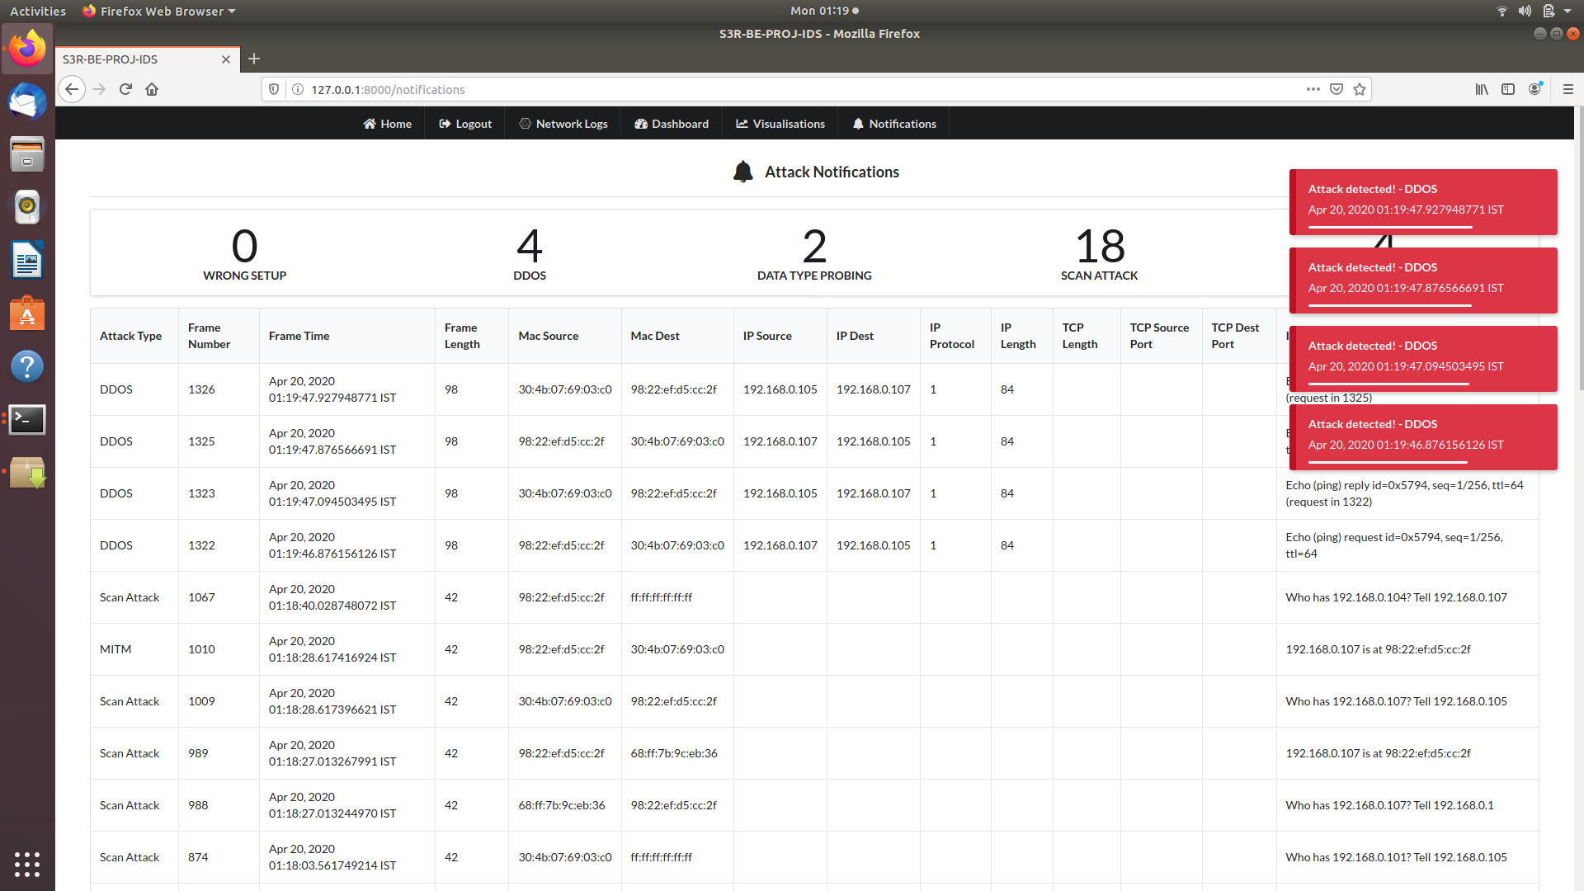
Fig 4.6 Notifications screen shot

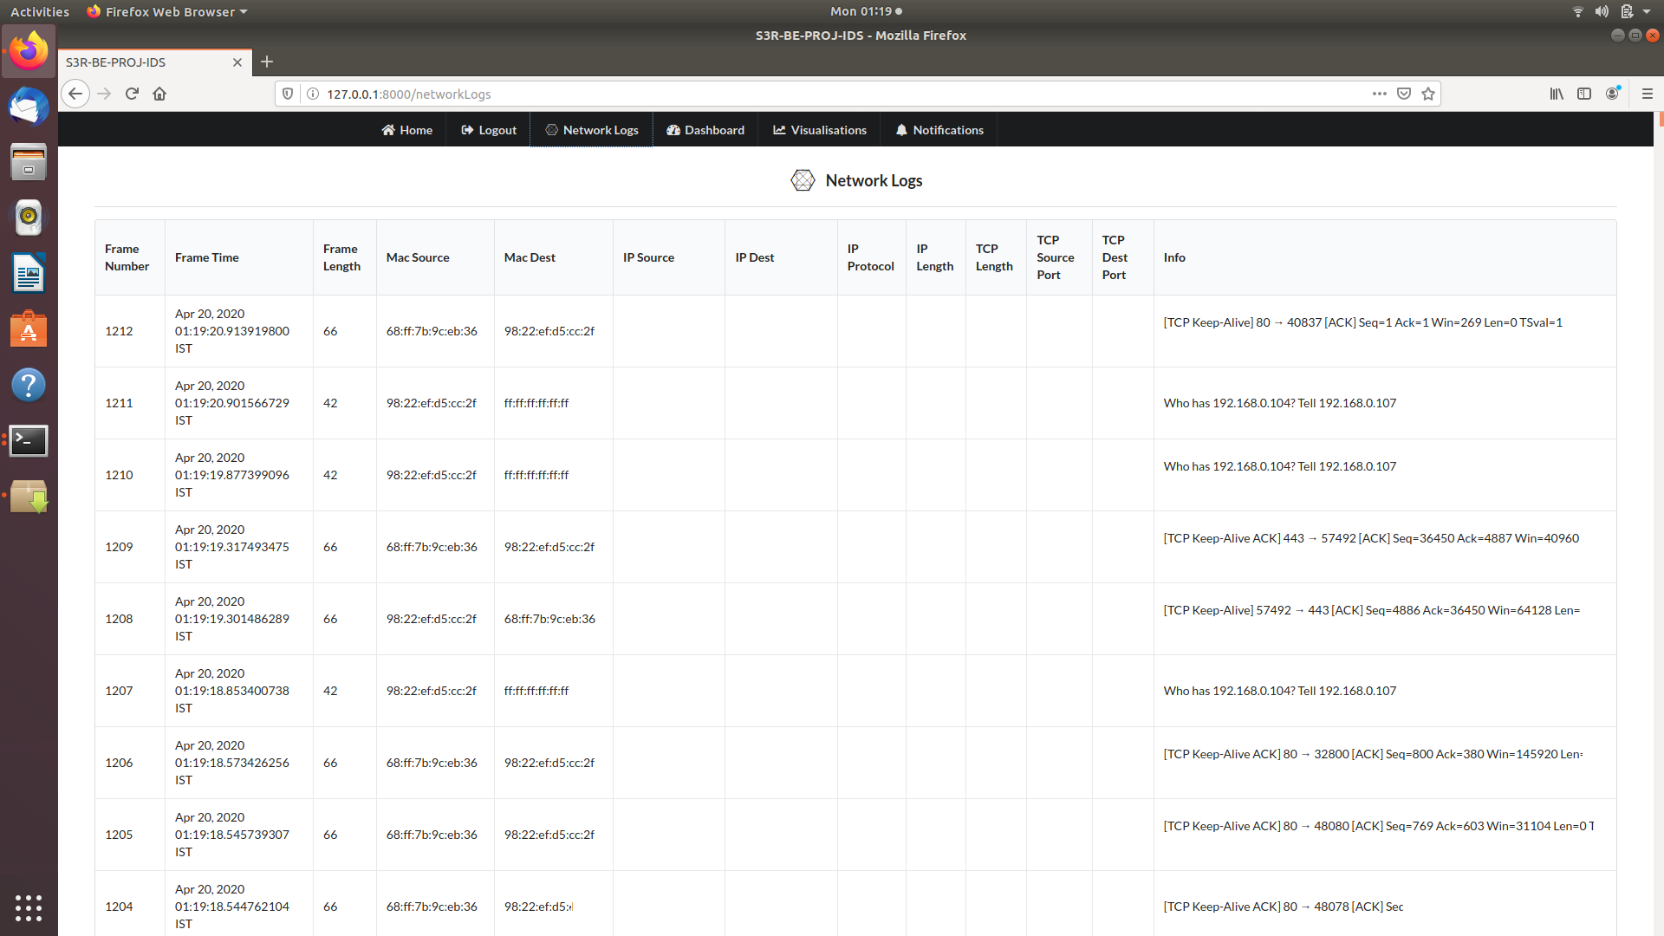
Fig 4.7 Network Logs screen shot

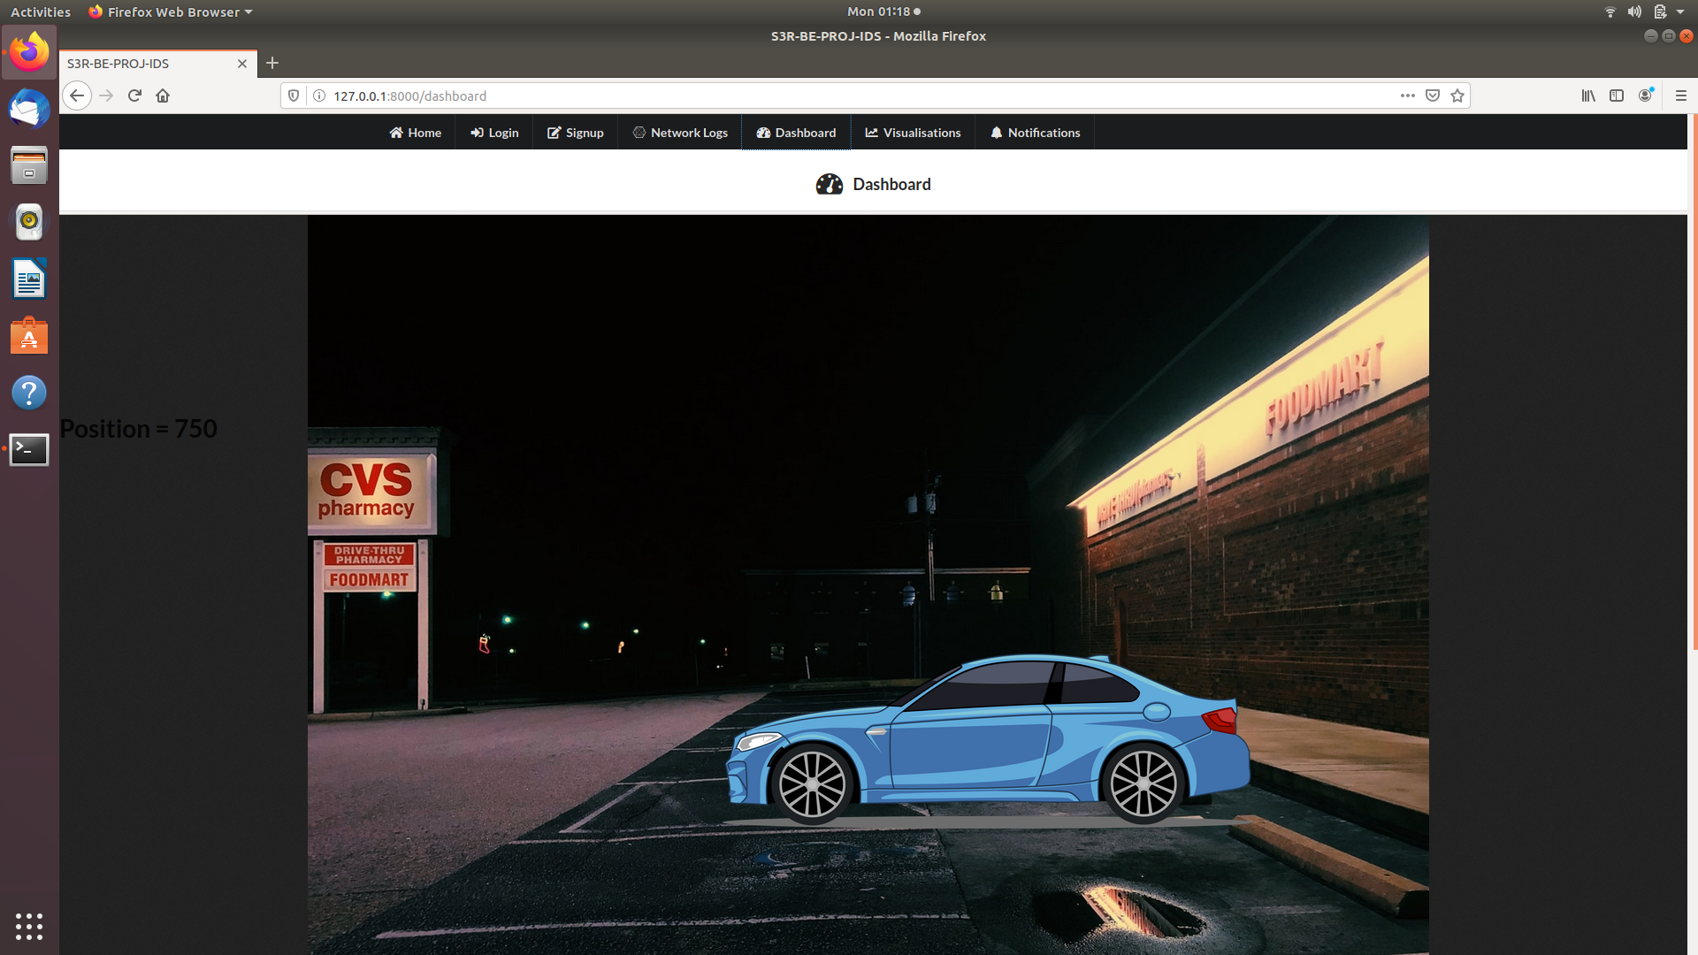
Fig 4.8 Dashboard screen shot

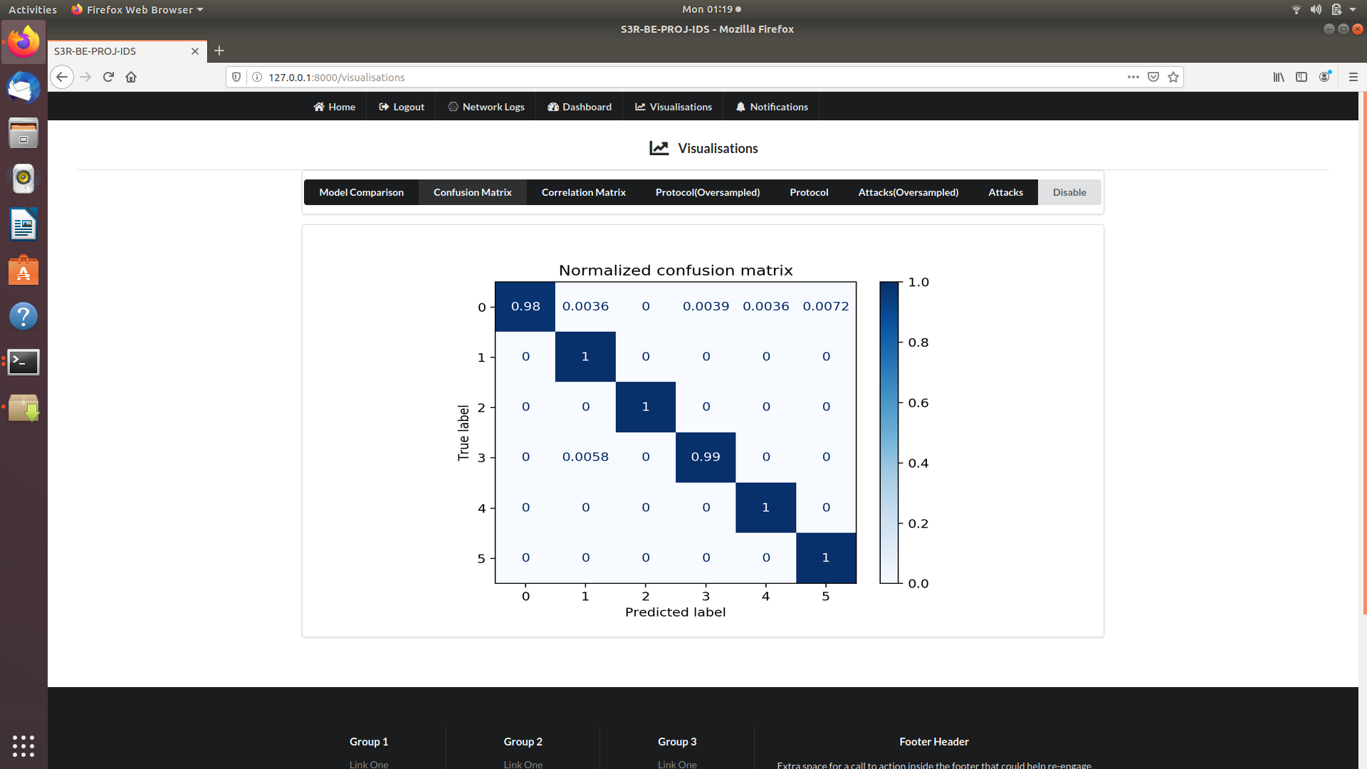
Fig 4.9 Visualisations screen shot

